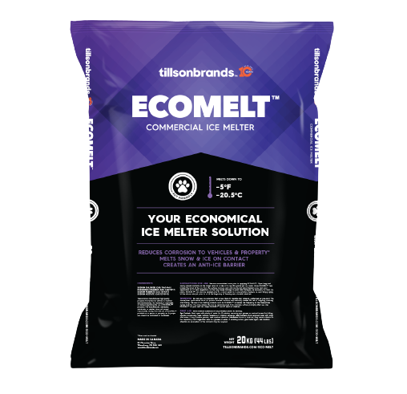

IN STOCK

Eco Melt Ice Melt

20kg $15.98

Item # 80002029